# Lt. Col. Mehar Little Angel Sr. Sec. School



Winter Holiday Homework Class – Nursery

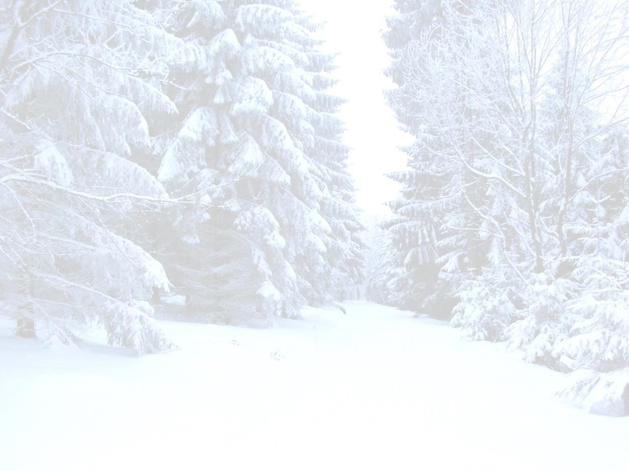I am little snowman, Short and fat.

Here is my scarf, And here is my hat.

When it’s cold and snowy

I will stay.

But when it gets hot,

I melt away.



Dear parents,

Enjoy the winter vacation with fun filled indoor and outdoor activities. Talk about the wonder of nature with your child. Share your childhood memories etc.

Children love to hear these stories. Creative activities like playing with clay, beads, paints and colouring are all time great favorites for the children. Along with fun and play kindly reinforce the work done in class.

## Reading assignment

**English**: Reading and recognition of letter A to Z with phonic sounds.

**Hindi:** Reading and recognition of Swar and Vyanjan.

**EVS**: Reading and recognition of topics: – Myself, parts of the body, My family, fruits, flowers, wild animals,

birds, means of transport, classroom articles.

**MATHS:** Oral counting 1 to 100.

## Written assignment

Kindly take the print out of the worksheets and help your ward to complete the same.

**NOTE:** Winter vacation starts from Jan 1 ,2025, i.e. Wednesday.

The school will re-open on Jan 16, 2025, i.e. Thursday.

**WISHING YOU A VERY**

**HAPPY NEW YEAR 2025**







